Lab October 14th

1A—write if statements

* Len(name) >18
* Print(length)

1B—for I in rage (8):

Print (“A” *i

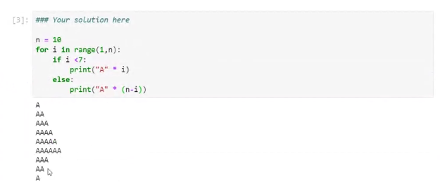

1C1—Max= max(data)

Print(Max)

=97

For count, use len()

Avg = Sum/count

Print(Avg)

Put it in P

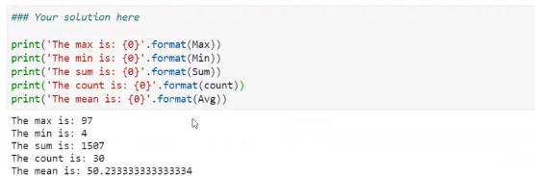

1D3—for I in range(len(data)):

Print(data[i])

OR

For element in data

Print(element)

New_list = []

For I in range(len(data)):

If 12< data[i] <80:

New_list.appenda

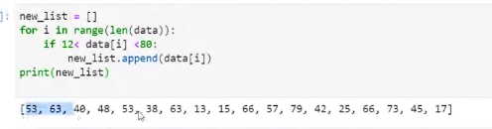

Full answer:

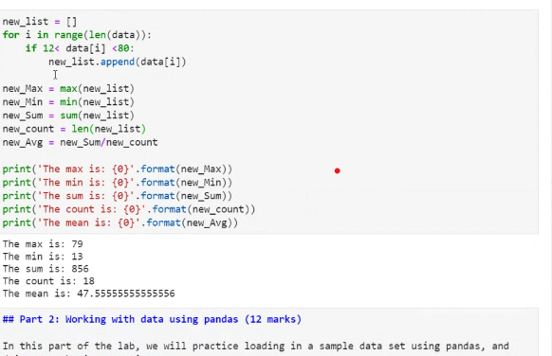

Or replace first lines with:

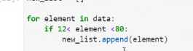

Or you can do this:

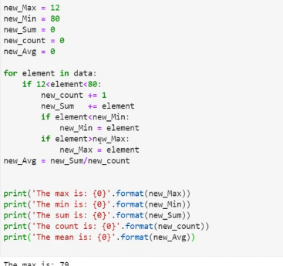

2A1

Import pandas as pd

pd.read_csv(“data/pokemon.csv”)

print(data.iloc[:5,:])

2A2

* Print(len(data))
  + 800

OR

* Data[‘Name’]

OR

* Data.iloc[:,1]

*1 refers to second column

** useful if you don’t know column name

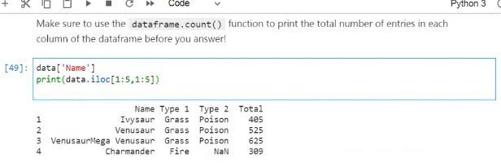

2A3/4 -- Data[data[‘Speed’]>80]

--- lists all pokemon whose speed is greater than 80

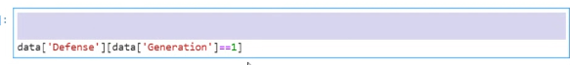

Part 3

3A

A= [a,2,4,”d”]

Print(A)

--prints list

Dictionaries

* As= {1: “a”, “something”: 2,3:30, “b”:6}
  + A[1]
    - “a”
    - A[“b”]
      * 3 --- that’s the key!

A= {‘name’:,

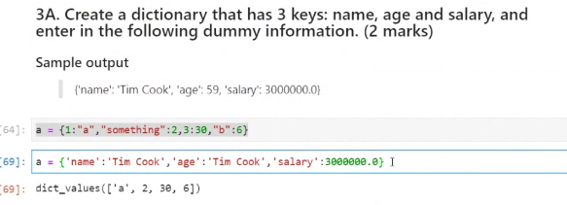

3B

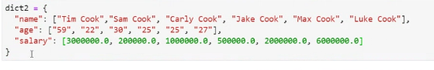

For I in dict.keys():

If dict2[‘age’]>25

Print(dict2[‘name’])

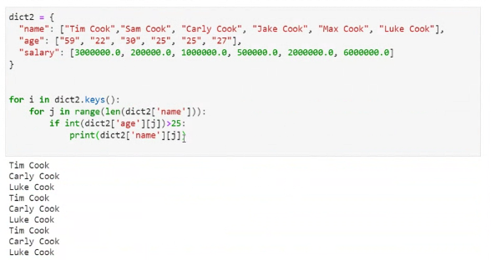

* Prints people with ages>25
* 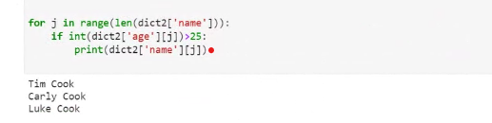
* 3C
  + D= pd.Dataframe([‘name’,’age’])
  + D

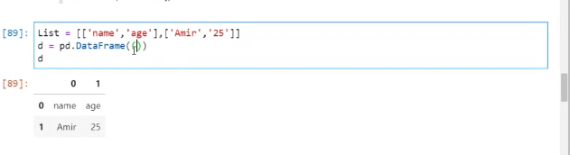

Creates list with dataframe

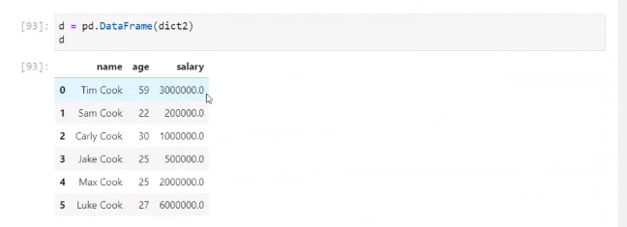

Here’s all you need to do

3D

D =pd.Dataframe[dict2]

d.columns = [‘new_name’, ‘new_age’, ‘new_salary’]